**DAILY ONLINE ACTIVITIES SUMMARY**

|  |  |  |  |  |  |  |  |
| --- | --- | --- | --- | --- | --- | --- | --- |
| **Date:** | **21/05/2020** | | | | **Name:** | **JYOTHI LAKSHMI** | |
| **Sem & Sec** | **8th sem, B sec** | | | | **USN:** | **4AL16CS0129** | |
| **Online Test Summary** | | | | | | | |
| **Subject** | | **SMS 2** | | | | | |
| **Max. Marks** | | **60** | | **Score** | | **60** | |
| **Certification Course Summary** | | | | | | | |
| **Course** | **Introduction to Ethical Hacking** | | | | | | |
| **Certificate Provider** | | | **Great Learning** | **Duration** | | | **40 mins** |
| **Coding Challenges** | | | | | | | |
| **Problem Statement:** C Program to Reverse a Linked List in groups of given size | | | | | | | |
| **Status: Completed** | | | | | | | |
| **Uploaded the report in Github** | | | | **Yes** | | | |
| **If yes Repository name** | | | |  | | | |
| **Uploaded the report in slack** | | | | **Yes** | | | |

Online Test Details:

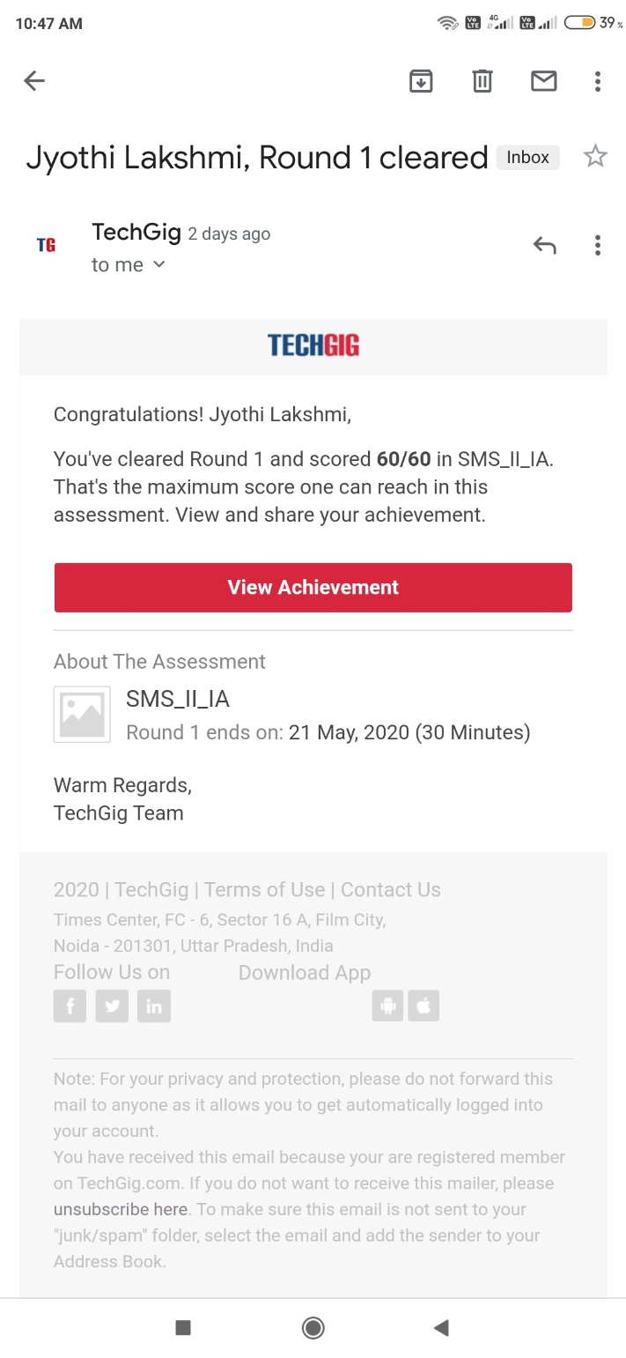

Online examination is conducting a test online to measure the knowledge of the participants on a given topic. With online examination students can do the exam online. The test was on the subject System Modeling and Simulation under the topic Random variate generation technique.

Certification Course Details:

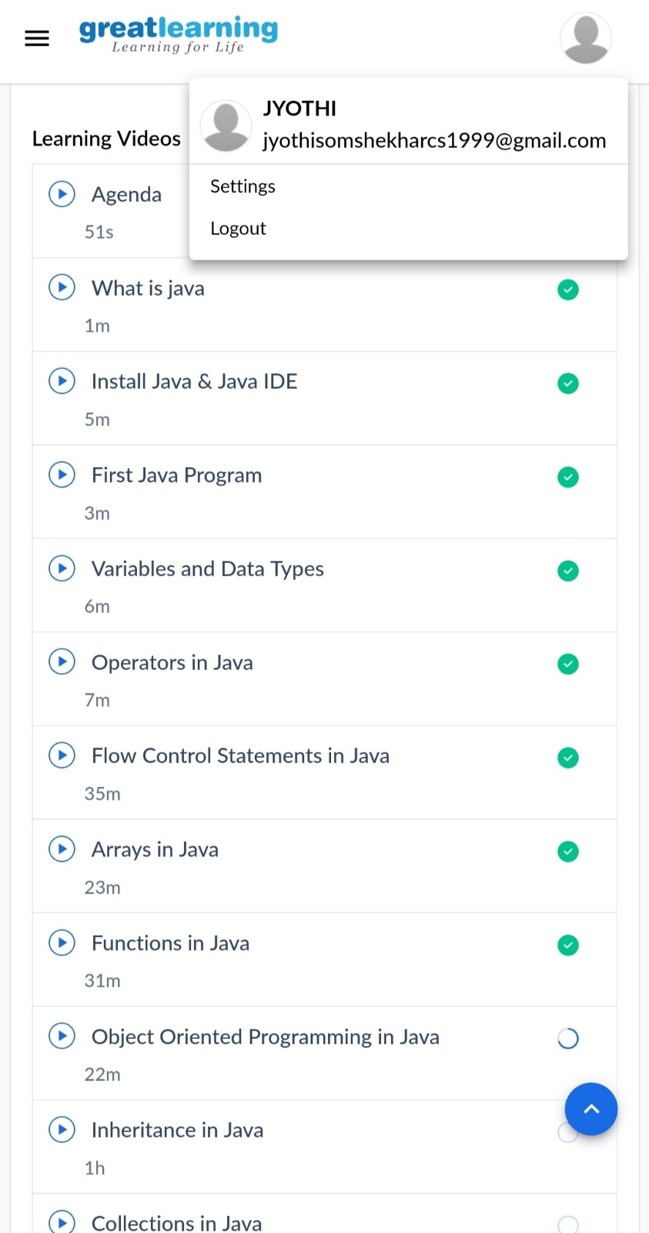

Coding Challenges Details:

